Launch jenkins and explore creating projects and users

Installation of Java(open JDK)

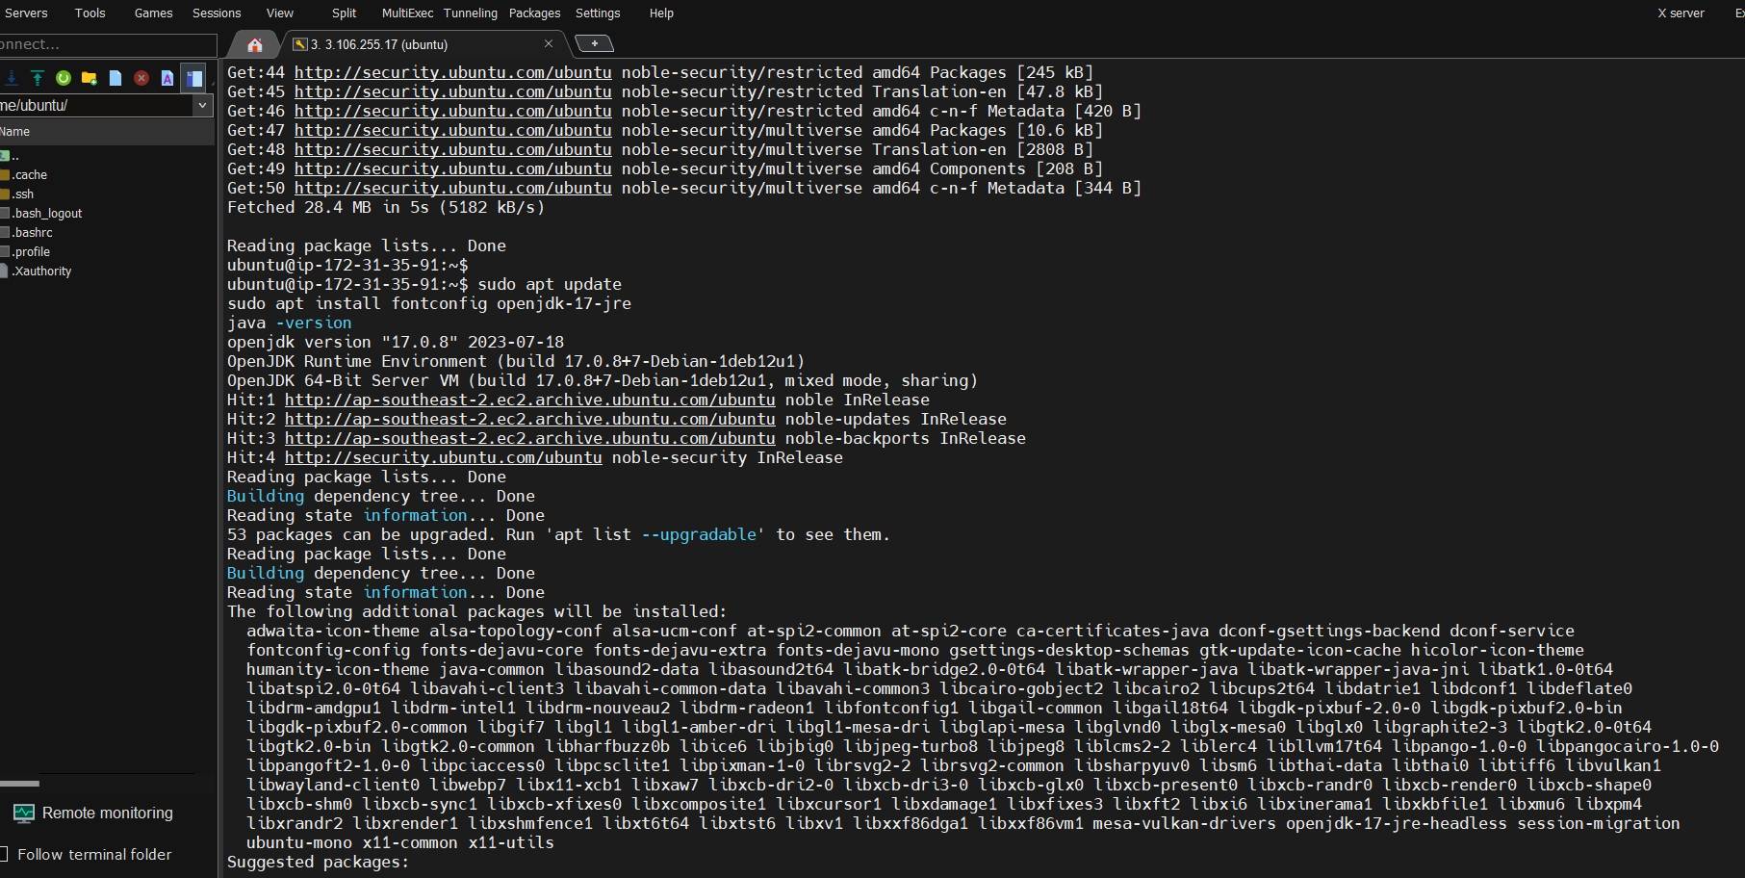

Java Version

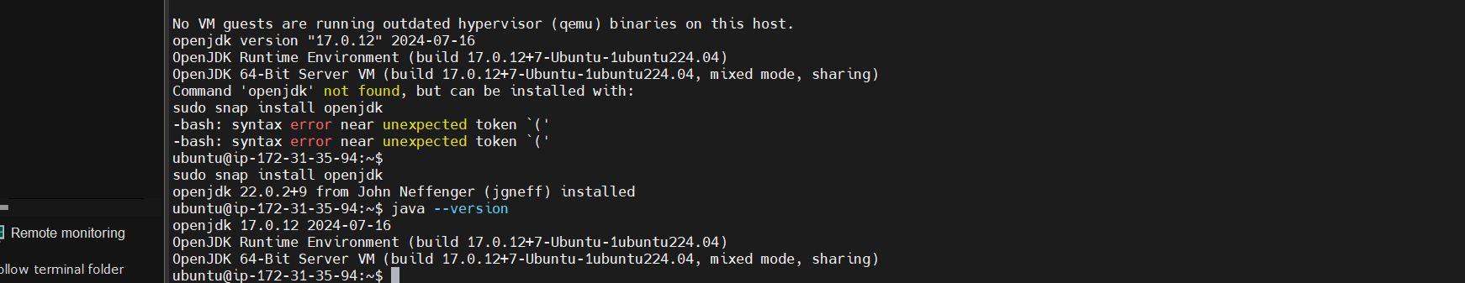

Install Jenkins using long term support release

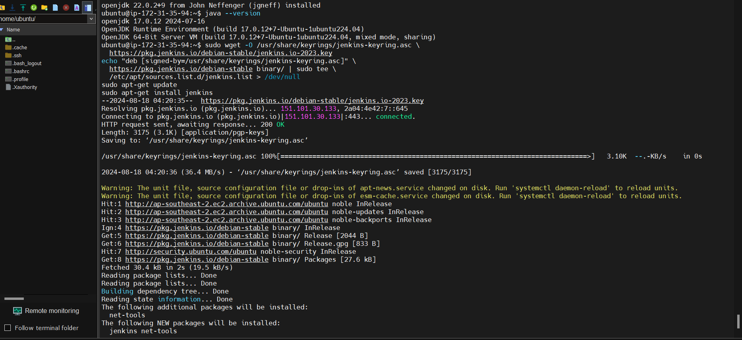

Start Jenkins

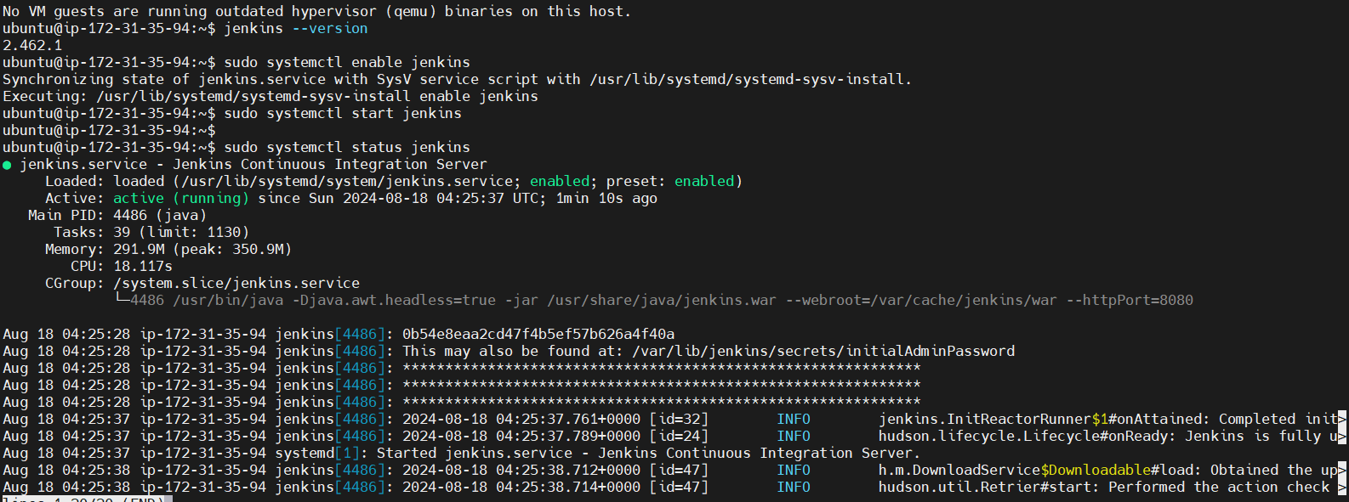

Unlock Jenkins using the passwor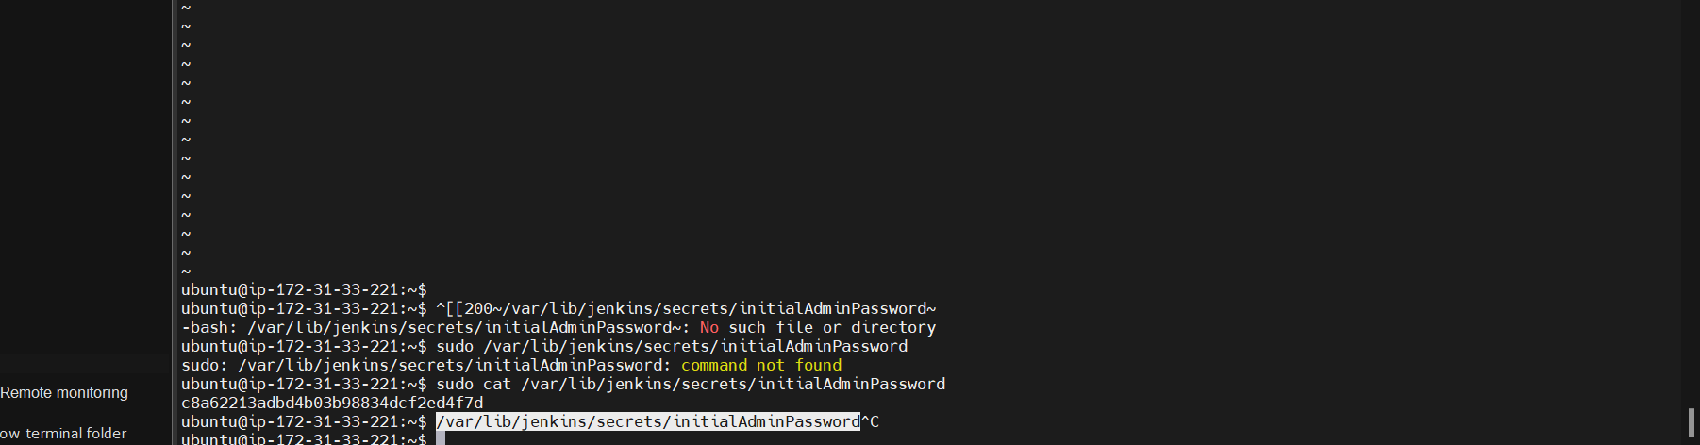

Jenkins Dashboard is ready

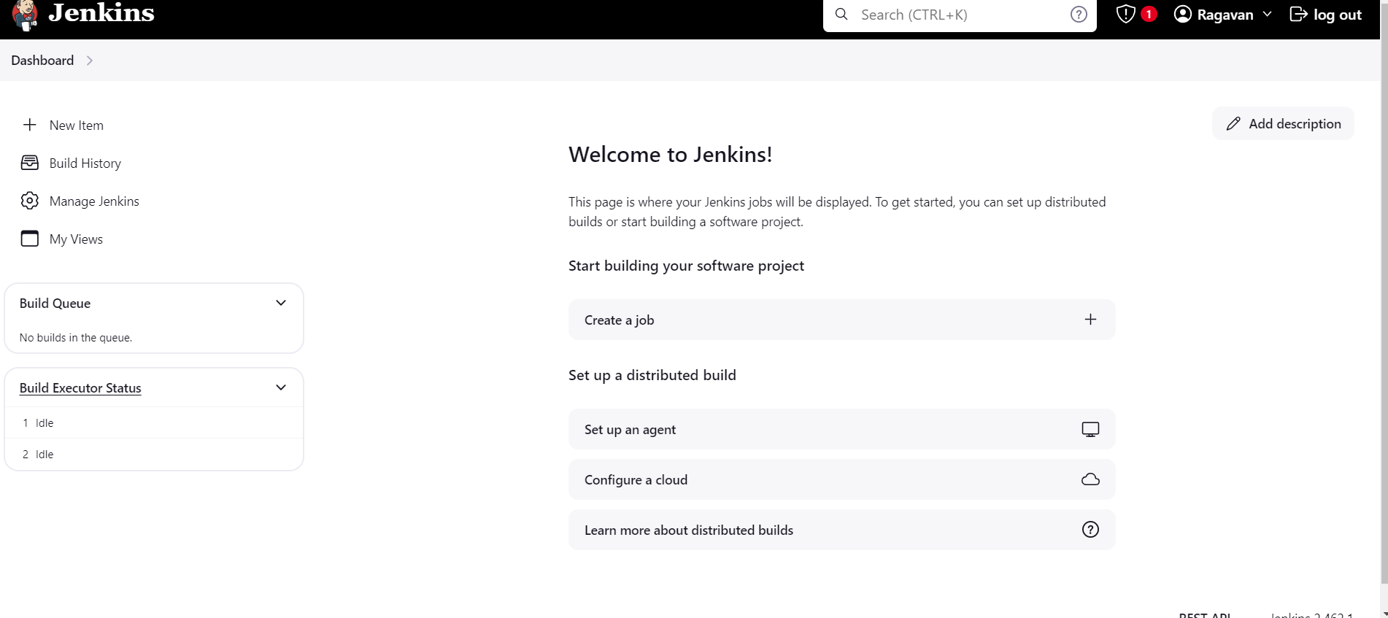

First project in Jenkins

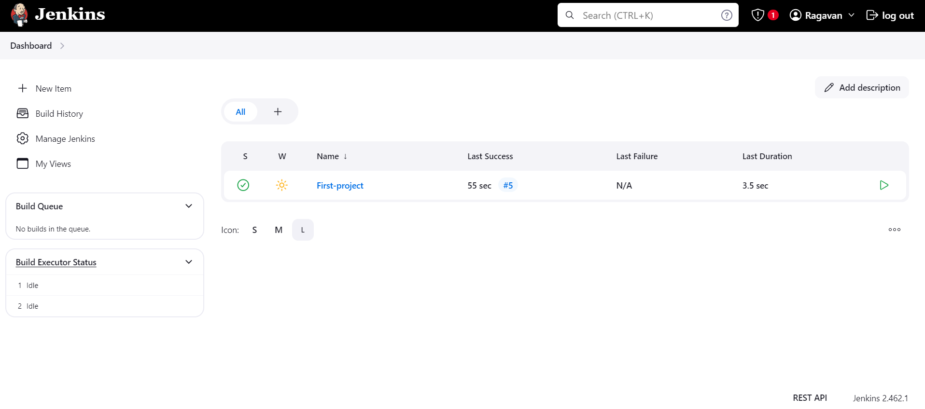

Console output

